**The Shield:**

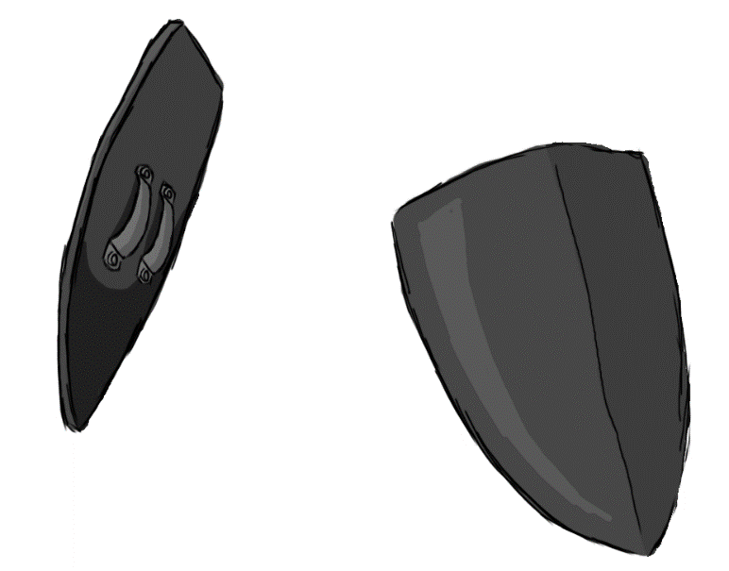

Figure 1 - Weapon: Shield

**Brief Synopsis**

The shield is a defence-based weapon used by the player character. The main draw for this weapon is its ability to keep the player from taking damage as well as packing large amounts of knockback with its attacks. That said the shield’s attacks will not deal any direct damage to enemies and act solely as a method for dealing with enemies in the players path or knocking enemies into hazards. In addition to this while equipped the shield will apply a minus 20% movement multiplier, slowing the player down.

**Special Ability**

**Shield Slide:**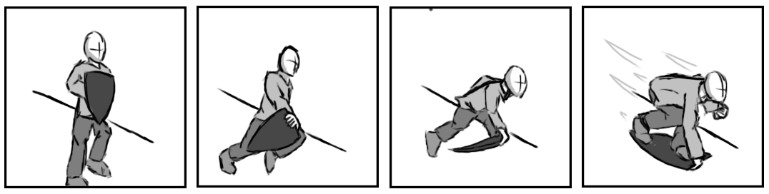

Figure 2 - Animation Storyboard: Shield Slide

**Special:** When used, the player leaps into the air and throws their shield beneath them. If used on a flat plane the animation will cancel back to the walking or idle after the player hits the floor. If on a slope or rail however the player will begin to slide downwards, accelerating gradually however with a much higher max velocity then running.

**Combat Ability’s**

**Block:**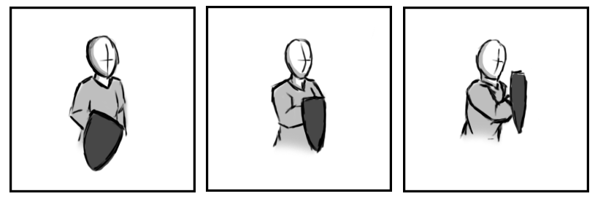

Figure 3 - Animation Storyboard: Block

**While grounded and stationary:** The player holds the shield in front of the player and blocks any attacks coming from with a 180-degree arc in front of the player.

**Charge:  
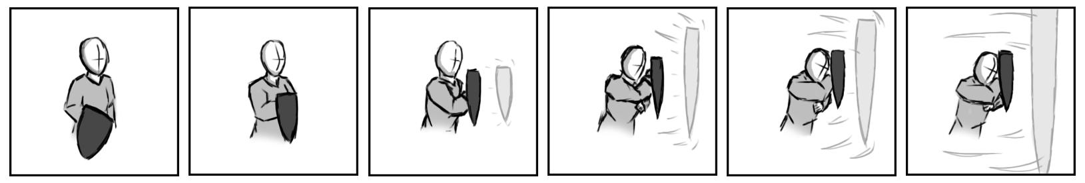**

Figure 4 - Animation Storyboard: Charge

**While grounded and in motion**: The player holds the shield in front of the player and charges forward this block any attacks coming from with a 180-degree arc in front of the player while also pushing any enemies that the player collides backwards and to the side.

**Shockwave:**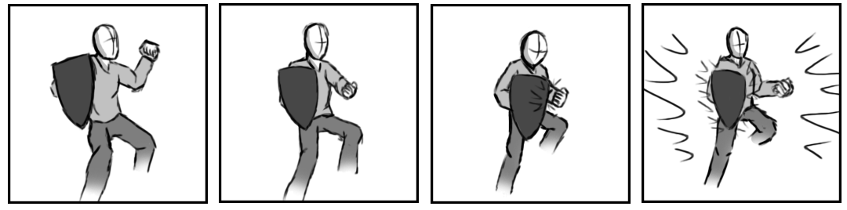

Figure 5 - Animation Storyboard: Shockwave

**While aerial:** This attack has the player hit their shield with their offhand causing it to vibrate releasing and shockwave around them, this will push back any enemies within close range.